


P. E. S. COLLEGE OF ENGINEERING

MANDYA – 571401
(An Autonomous Institution Affiliated to VTU, Belgaum)

“REAL-TIME CHAT APPLICATION USING SOCKET.IO”
MINI PROJECT SYNOPSIS
OF
BACHELOR OF ENGINEERING
IN
DEPARTMENT OF COMPUTER SCIENCE AND BUSINESS SYSTEMS SUBMITTED BY
Harshitha K Santhosh D Vismay B S Namratha G R
[4PS23CB020] [4PS23CB040] [4PS23CB049] [4PS24CB404]

Guided by
Dr. GEETHANJALI T M
Program Head
Department of Computer Science and Business Systems

DEPARTMENT OF COMPUTER SCIENCE AND BUSINESS SYSTEMS 2025-2026

Real-Time Chat Application using Socket.IO

Introduction

Communication systems have evolved significantly with the development of the internet and modern web technologies. Real-time communication applications such as chat platforms have become an essential part of daily digital interaction. These systems allow users to send and receive messages instantly through web or mobile applications.

A real-time chat application enables users to communicate with each other instantly without refreshing the page. This type of application uses technologies that support real-time data transfer between the client and the server. One of the most widely used technologies for this purpose is Socket.IO.

Socket.IO is a JavaScript library that enables real-time, bidirectional communication between web clients and servers. It works on top of WebSockets and provides features such as event-based communication, automatic reconnection, and low-latency message transmission.

In this project, a real-time chat application will be developed using Node.js for the server-side environment and Socket.IO for real-time communication. The system will allow multiple users to join a chat interface and exchange messages instantly.

The application will include features such as user connection notifications, instant message delivery, and real-time updates without page reloads. This project demonstrates the practical implementation of real-time web technologies and provides hands-on experience in full-stack development.

The system helps students understand modern web communication techniques and how real-time applications such as messaging platforms are built.

Objectives:

The main objectives of the project are:

• To develop a real-time web-based chat application.
• To implement instant communication between multiple users.
• To use Socket.IO for real-time bidirectional communication.
• To create a simple and user-friendly chat interface.
• To demonstrate the use of Node.js for backend development.
• To understand event-driven programming in web applications.

Feasibility Study:

A feasibility study is performed to determine whether the proposed system can be developed successfully within the available resources and time.

Technical Feasibility

The project is technically feasible because it uses widely available technologies such as Node.js, Socket.IO, HTML, CSS, and JavaScript. These tools are open-source and well documented, making the development process easier.

Economic Feasibility

The system is cost-effective because it uses free and open-source technologies. No additional hardware or paid software is required.

Operational Feasibility

The application is simple and easy to use. Users only need a web browser and internet connection to access the chat interface.

Time Feasibility

The project can be completed within the academic timeline since the technologies involved are lightweight and easy to implement.

Methodology/ Planning of work:

The development of the chat application follows several stages:

1. Requirement Analysis

Understanding the system requirements and defining the basic functionalities such as sending messages, receiving messages, and user connection handling.

2. Environment Setup

Installing necessary tools such as Node.js, npm, and required libraries including Socket.IO.

3. User Interface Design

Designing a simple chat interface using HTML and CSS where users can type and view messages.

4. Server Development

Developing the backend server using Node.js to manage client connections and message broadcasting.

5. Real-Time Communication

Implementing Socket.IO to establish real-time communication between the client and server.

6. Message Handling

Developing functionality to send messages from one user and broadcast them to all connected users.

7. Testing

Testing the application with multiple users to ensure messages are delivered instantly.

8. Deployment and Documentation

Finalizing the project, documenting the implementation, and preparing the project report.

Software/Hardware requirements:

Hardware Requirements

• Computer or Laptop
• Minimum 4 GB RAM
• Processor: Intel i3 or higher
• Internet connection

Software Requirements

• Operating System: Windows / Linux
• Backend Technology: Node.js
• Real-time Communication Library: Socket.IO
• Frontend Technologies:

HTML

CSS

JavaScript
• Code Editor: VS Code

Benefits of the project for the society:

The real-time chat application demonstrates how instant communication systems can be developed using modern web technologies. Such systems are widely used in many real-world applications.

This project can be extended for various applications such as:

• Online customer support systems
• Team collaboration platforms
• Social networking applications
• Educational communication platforms
• Live discussion forums

The project also helps students understand real-time communication technologies, event-driven programming, and full-stack web development.

Schedule of Project work completion:

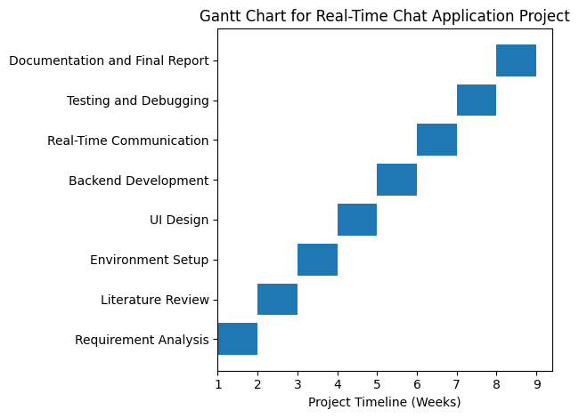

Figure 1: Gantt Chart Showing the Schedule of Project Work for the Real-Time Chat Application using Socket.IO

References:

Socket.IO Official Documentation – https://socket.io

Node.js Official Documentation – https://nodejs.org

MDN Web Docs – WebSocket and Real-time Communication

Tutorials and articles on real-time web applications

Research papers related to web-based communication systems

